**1. WAP to collect the number using pop up box and check that number is even or odd, show message to user using alert box in javascript.**

**Code:**

<!DOCTYPE html>

<html lang="en">

<head>

<meta charset="UTF-8">

<meta http-equiv="X-UA-Compatible" content="IE=edge">

<meta name="viewport" content="width=device-width, initial-scale=1.0">

<title>pop</title>

</head>

<body>

<script>

pop = prompt("Enter Number");

if (pop % 2 == 0) {

alert("Even Number");

}

else {

alert("Odd Number");

}

</script>

</body>

</html>

**Output:**

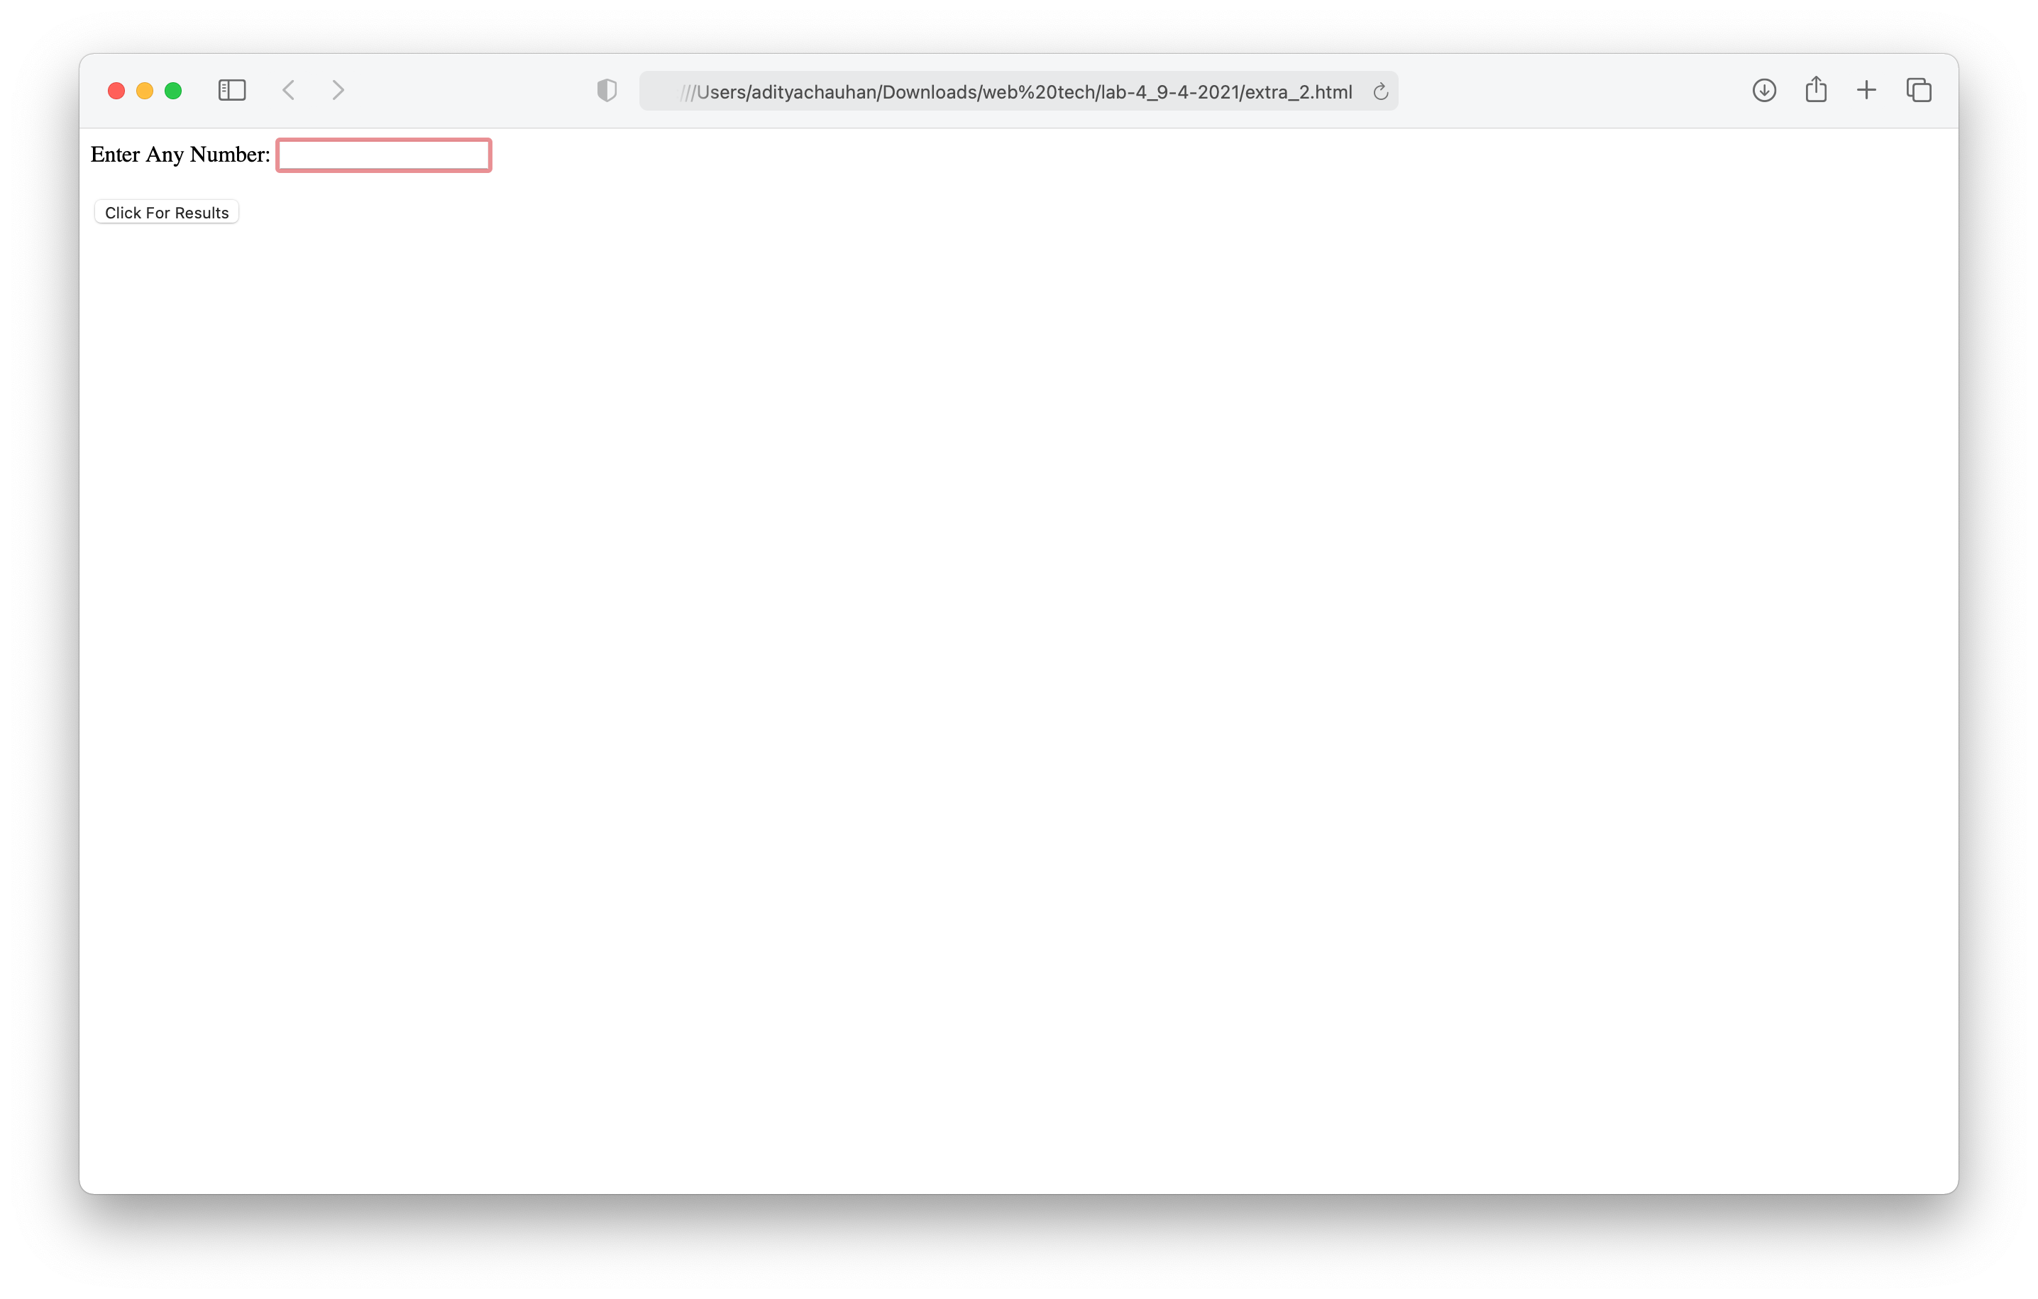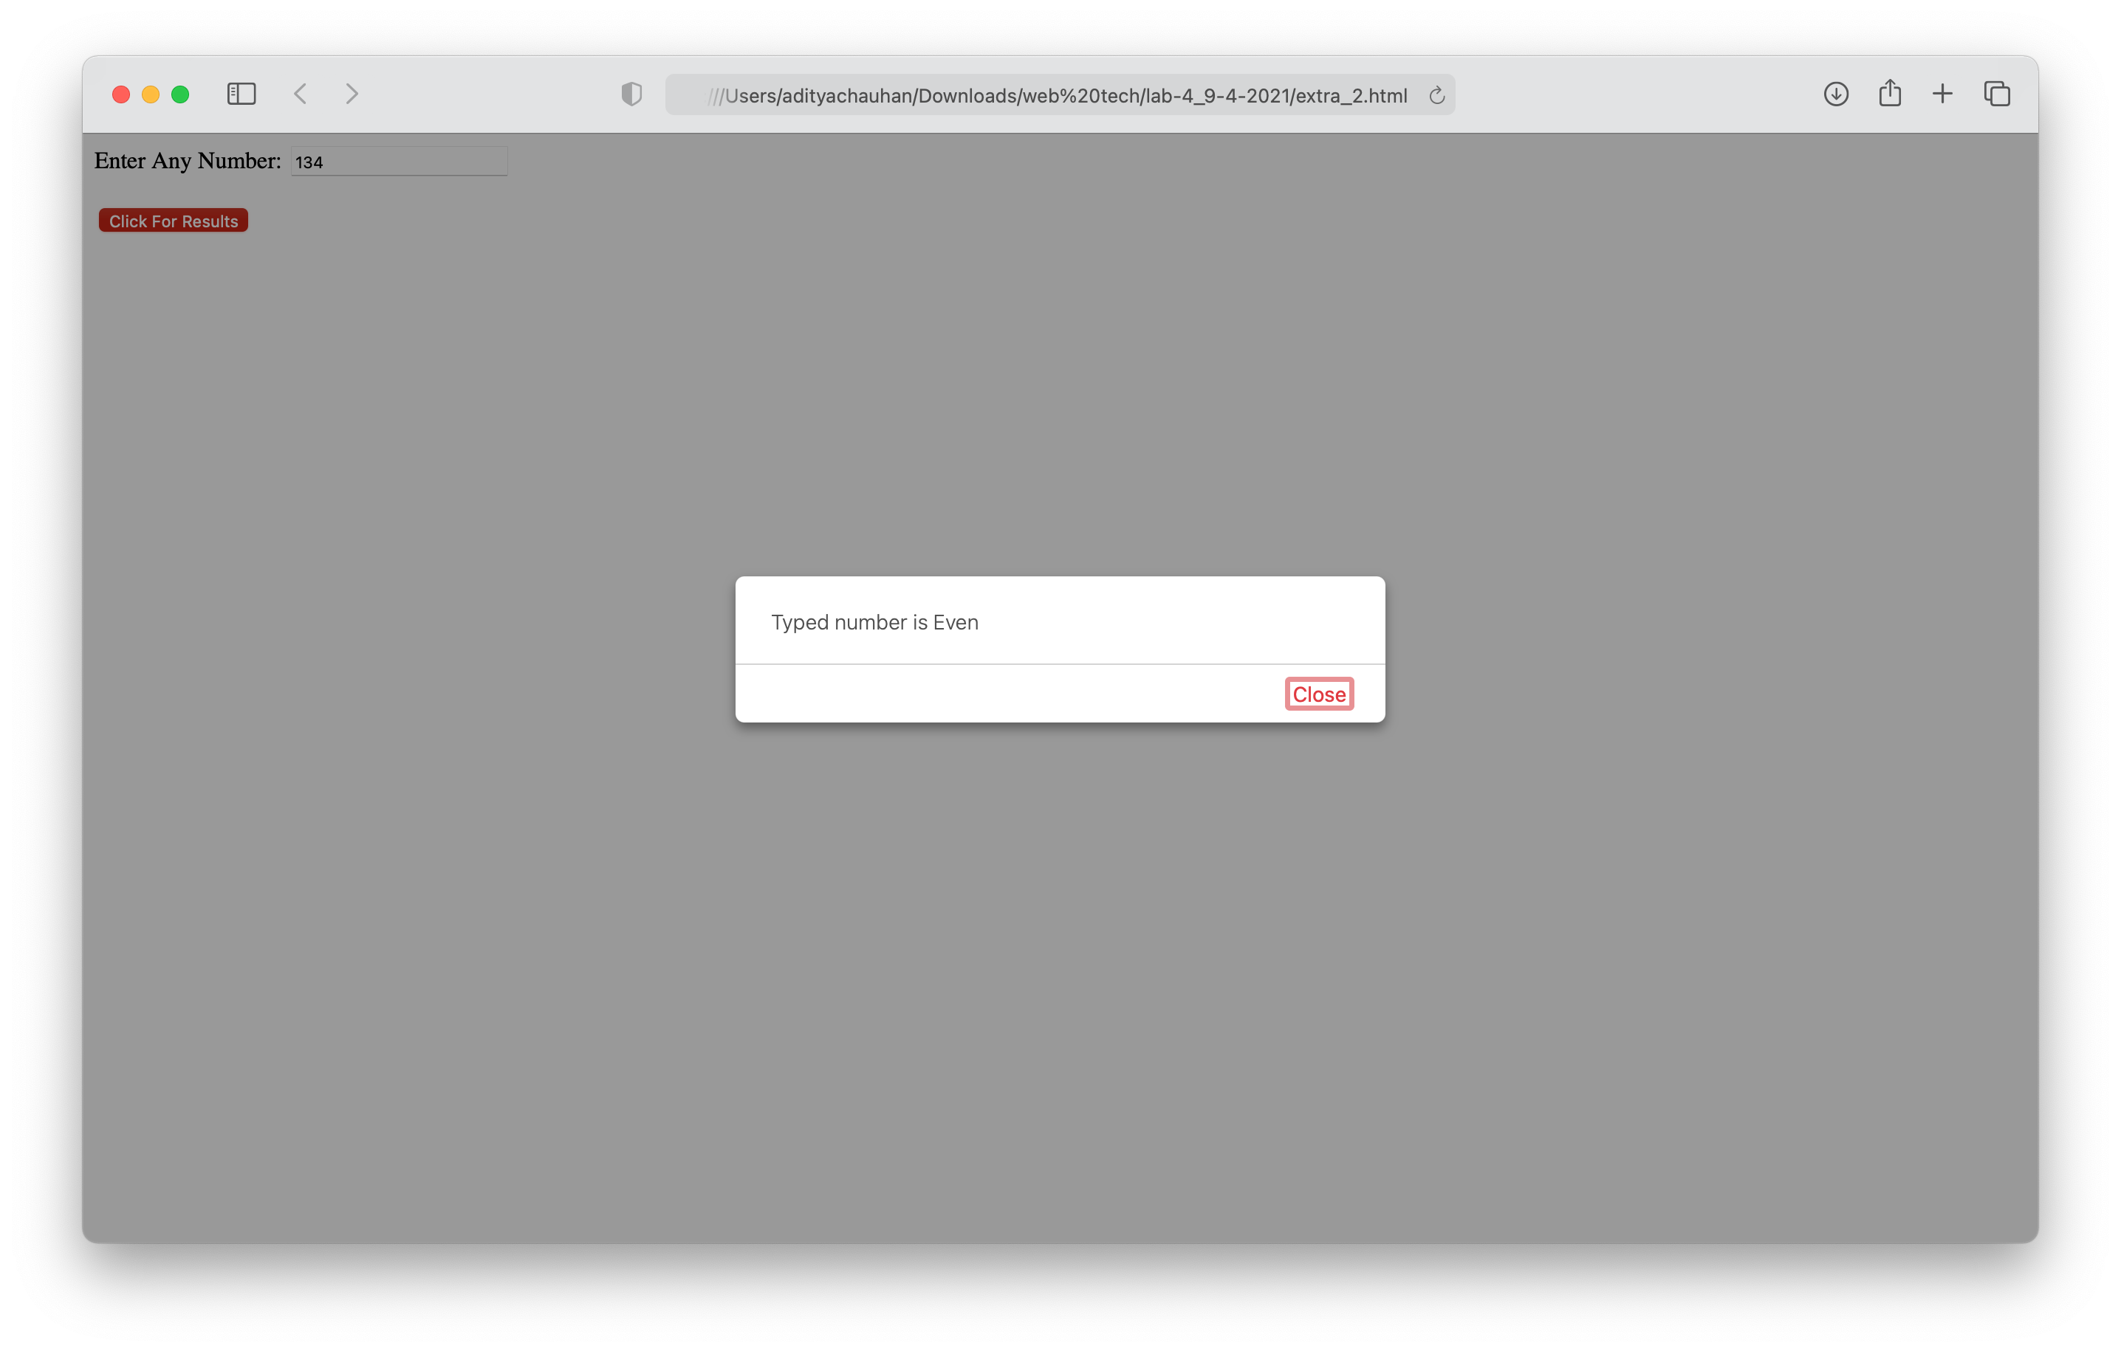

**2. WAP to change the content of an HTML element using Javascript.**

**Code:**

<DOCTYPE! html>

<head><title>Demo of javascript</title></head>

<body>

<h2>What can JavaScript Do ?</h2>

<p id="Demo">JavaScript can change Html content.</p>

<button type="button" onclick='document.getElementById("Demo").innerHTML

="Hello JavaScript!"'>Click Here!</button>

<script type="text/javascript">

window.alert("THIS WEBSITE IS FOR PERSONAL USES")

</script>

</body>

</html>

**Output:**